A Project Report

On

**“RESTURANT MANAGEMENT PROJECT”**

Submitted By

**MR. AAKASH JAGDISH BHAI PATEL**

Submitted To



**Naran Lala College of Professional and Applied Sciences,**

**Veer Narmad South Gujarat University, Surat.**

**Year: 2022-2020**



**NARANLALA**

**COLLEGE OF PROFESSIONAL & APPLIED SCIENCES**

**BHAGVATI SANKUL, NEAR ERU CHAR RASTA,**

**NAVSARI – 396 450**

**CERTIFICATE**

This is to certify that **MR. AAKASH JAGDISH BHAI PATEL,** Exam No.16 student of **B.C.A. 5th** **semester** of our college have successfully prepared and submitted Project Report on “Online Herbal Shopping” as a partial fulfillment for the course of **Bachelor of Computer Application (Minor Project Sem. V)** during the academic year **2022-2023**.

__________________ __________________

**DATE Guide: DR. HARDIK V .**

**DESAI**

_________________ __________________

**Dr. S. M. NAIK Dr. A. B. PATEL**

**(I/C PRINCIPAL, NLCPAS) (DEPT. HEAD, BCA)**

________________

**(EXTERNAL EXAMINER)**

INDEX

|  |  |  |
| --- | --- | --- |
| SR.NO | TOPIC | PAGE  No. |
| 1. | **Preface** |  |
| 2. | **Acknowledgement** |  |
| 3. | **Introduction** |  |
| 4. | **System requirement specification** |  |
|  | **4.1 Project profile** |  |
|  | **4.2 module** |  |
|  | **4.3 front-end** |  |
|  | **4.4 back-end** |  |
| 5. | **System objective** |  |
| 6. | **System scope** |  |
| 7. | **Data flow diagram** |  |
| 8. | **Data dictionary** |  |
| 9. | **Screen layout** |  |
| 10. | **Testing** |  |
| 11. | **Conclusion** |  |
| 12. | **Bibliography** |  |

Preface

It gives a great pleasure in the hands of our esteemed faculties this individual reports, which, we believe will go through the documentation of the project work done by me.

The objectives of this report are to provide both a conceptual understanding of the system as well as working guide. Surely, on other technology as information technology is proven as the driving force of the nation I.T not only decides the present but also the future. The need for software development today is a competence in a G.U.I based front-end tool as for as the database programing connected.

A typical scenario today involves an application consisting of a visual studio front-end for presenting data and reporting option to the enterprise users, and connection to a database for piping data to control such as textboxes, tables and radio button. These applications typically feature report to provide information about the book to end users. As a student of BCA when we require all the theoretical knowledge, it is both necessary and advisable to acquaint the students with the real situation through, well-planned project in relevant fields. Using all the real application the students earns to develop efficient real world application at the time of project training.

Acknowledgement

First, I thank to South Gujarat University for giving us the Opportunity to undergo the dissertation project.

This project work is an integrated effort of all those concerned though the project whose co-operation and effective guidance helped us to complete this project work.

I express my sincere gratitude to **DR. HARDIK V. DESAI** For giving me best Opportunity to this exciting project and spending many hours revising the contents of this project report and for his advice and encouragement during long task of developing the project.

I would like to thank to our Director. For giving me a chance for trainee software developer. Also a special thanks to me head of computer department. Mr. Ashish Patel for giving the guidance about my project.

We would like to thank our college internal guide to Mr. Ashish Patel. For being assisting us in our project. We would like to thank our friends and all those persons who have directly or indirectly helped us in making this project work and successful.

**Yours Sincerely,**

**Aakash patel**

Introduction

This project helps the users in curing its disease by giving the list of Herbal that the user should consume in order to get rid of its disease. The main purpose of this project is to help the user to easily search for herbal that will be good for the health of the user depending on any health issue or disease that he/she is suffering from. This system helps the user to reduce its searching time to a great extent by allowing the user to enter its health problem and search accordingly. The admin can add Herbal to the system and its information. This system also allows the user to view the selected fruit or the herb’s description which describes how the herb will help to improve the user’s health. This system also allows the user to place order which will add the items to the user’s cart. The system also includes a module in which the user can search for the hospitals depending on the name of the disease that it enters. Thus this system helps to cure the user’s disease to a great extent. The system also allows user to search for hospitals depending on the entered disease name. Thus this system helps to improve health by suggesting fruits or herbal depending on the disease entered by the user and also allows to place order for the same.

System Requirement Specification

System requirement are expressed in a software requirement document. The software requirement specification (SRS) is the official statement of what is requirement of the system developers. This requirement document includes the requirement definition and the requirement specification.

The software requirement document is not a design document. It should set out what the system should do without specifying how it should be done.

The requirement set out in this complete and consistent.

The software is specification document satisfies

The following:-

1. It specifies the external system behaviors.
2. It specifies constraints on the implementation.
3. It is easy to change.
4. It serves as reference tool for system maintainers.
5. It records forethought about the life cycle of the system.
6. It characterizes acceptable response to undesired event.

Project Profile

|  |  |
| --- | --- |
| Project Title : | RESTAURANT MANAGEMENT SYSTEM |
| Project scope : | 1. Information of Restaurant management  2. Capturing insert ,update ,delete ,read  Of food. |
| Developed By : | Aakash J. Patel |
| Project Guide By : | Dr.Hardik v. desai |
| Front-End : | PHP (visual studio code) |
| Back-End : | MYSQL |
| Organization : | Naran Lala College of professional  and applied Science |
|  |  |
|  |  |

MODULE

ADMIN SIDE MODULE

**Manage User detail**-

Admin can view the user personal information. Admin also can grant and revoke the privileges on the access of product information and purchasing a product or medicine.

**Manage insert detail-**

Admin can store the insert information and also store the food information which supplied by particular admin.

**Manage Display detail-**

Food items information can store in Restaurant database. Which supplied by different company and different supplier.

**Manage Update detail-**

Administrator can view all the orders and their details. Administrator /Users can update the details of particular food .

.

USER SIDE MODULE

**Registration-**

Users who want to buy the Herbs they have fill up Registration form.

**Login-**

Once user registered they directly Login for purchasing the Herbs.

**Viewing-**

New users who register can view the all food product and also view the detail information of particular food product of herbs with their information and benefits. They also view the detail of the food .

Front-End

The **PHP Hypertext Preprocessor (PHP)** is a programming language that allows web developers to create dynamic content that interacts with databases. PHP is basically used for developing web based software applications

* PHP can generate dynamic page content.
* PHP can create, open, read, write, delete, and close files on the server.
* PHP can collect form data.
* PHP can send and receive cookies.
* PHP can add, delete, and modify data in your database.
* PHP can be used to control user-access.
* PHP can encrypt data.

**How to Learn PHP: Step-by-Step Guide**

1. Step 1: Learn HTML and CSS. PHP is a great programming language to learn, but it should not be the first technology you master in web development. ...
2. Step 2: Master the Basics.
3. Step 3: Build a Project.
4. Step 4: Focus on Readability.
5. Step 5: Join PHP Communities.
6. Step 6: Get in Some Practice.

BACKEND (MYSQL DATABASE)

**What is MySQL?**   
[MySQL](https://www.geeksforgeeks.org/structured-query-language/) is an open-source relational database management system (RDBMS). It is the most popular database system used with PHP. MySQL is developed, distributed, and supported by Oracle Corporation

* The data in a MySQL database are stored in tables which consists of columns and rows.
* MySQL is a database system that runs on a server.
* MySQL is ideal for both small and large applications.
* MySQL is very fast, reliable, and easy to use database system.It uses standard SQL
* MySQL compiles on a number of platforms.

## **Open a Connection to MySQL**

### **Example (MySQLi Object-Oriented)**

<?php

$server = "localhost";

$user = "root";

$pass = "";

$database = "26";

$conn = mysqli_connect($server, $user, $pass, $database);

if (!$conn) {

    die("<script>alert('Connection Failed.')</script>");

}

?>

Objective of this system :-

It will display the complete Details reports, Summary Report of particular year and month wise, Infrastructure Detail Report, Link Summary Report and Work Completed Report also.

* To shop wile in the comfort of your own home, without having to step out of the door.
* Sell at lower rate due to less overhead.
* Provide home delivery free of cost.

.

Scope of this System

This product has great future scope. This Project also provides security with the use of Login-id and Password, so that any unauthorized users can not use your account. The only Authorized that will have proper access authority can access the software.

1. Capturing of day to day transaction through interactive screen and validation of the transaction will be provided.
2. To provide up to date information.
3. Providing security and data integrity by restricting access through password. Provide validation at the point of data entry.
4. Avoid data redundancy.
5. Provided shared database.
6. Fast access to data.
7. Quickly produce information for decision making process of management.
8. Better consumer service

CONTEXT LEVEL DFD

Customer

View customer info

Manage food info

Read data Get customer information

Get product data

Admin

insert ,update ,delete

1st LEVEL DFD FOR OVER ALL SYSTEM

Fill Detail Register info

Admin

Give info Get info

Give info view appropriate deal

Client

Get Verified message Give information

Food menu

FOOD_NAME

Read data

FOOD_PRICE

Read data

Read data DELETE

Read data UPDATE

2nd LEVEL DFD FOR PRODUCT PROCCESS

Client

View food iteam

Store Product detail

Login & register

Product_master

Manage Food item &

Insert,update,delete

Admin

Get report

Data Dictionary

The data dictionary of any system is integral component of structure analysis, since data flow diagrams by themselves do not fully describe the subject under investigation about the system.

A data dictionary is a catalog – a repository – of the elements in the system. These elements canter on data and the way they are structured to meet user requirement and organization needs. This step of creating a data dictionary is simultaneous with the process of making data flow diagram(s). Here all the data fields in their respective tables are allotted so as to access these data in the system. The data tables are created in a back-end tool like MYSQLI. Here in the Department information System we are using tables created in MYSQL as it is the back-end tool used in the system.

The data dictionary consists of different major elements like data Element like Data elements, Data Store [Tables Used], Data Flow, Processes and other External entities used in the system, the data dictionary stores details and description of these elements.

It is developed during data flow analysis and assists the analysts involves in determining the system requirements. Analysts use data dictionary for the following important reasons:

* To manage the details in large system.
* To communicate a common meaning for all system elements.
* To document the features of the system.
* To facilitate analysis of the details in order to evaluate the characteristics and determine where system changes should be made.
* To locate errors and omissions in the system.

The data dictionary contains different type of descriptions for the data flowing through the system:

**Data Element** is the most fundamental level is also considered as the building block for all other data in the system. It refers to all the different data used like fields, data item, etc. to make the system fully functional irrespective to the table used in the system. Here all the different type of fields used to make table are written sequentially without referring to the tables. This process helps in the process of ***Normalization*** of tables. Next to Data Elements comes the ***Data storage*** which provides the information of where and how each data element is stored in which table and it also give information of any constraints if there. This step also gives knowledge of different data types used for different field and their size. All the normalized tables are showed in data storage.

***Data Dictionary 1: 26(data base)***

|  |  |
| --- | --- |
| Name | Client_ master |
| Alias Name | ------------ |
| Where used | For search client information |
| How to used | For provide client information |
| Content Description | Table contain of city master has four fields that are : user name, email, password,confirm password |
| Primary Key | User_name |
| Foreign Key | Null |

|  |  |  |  |
| --- | --- | --- | --- |
| *Field name* | *Data type* | *Description* | *Validation* |
| User name | Text | user name | Only character |
|  |  |  |  |
| Email | Text | Email id of client | Accept all character |
| password | Text | Password | Reguirefield validator |
| Password | Text | Password | Reguirefield validator |

**Data Dictionary 14: user_detail**

|  |  |
| --- | --- |
| Name | User_detail |
| Alias | **----------** |
| Where used | **To search for user information** |
| How to used | **To provide user information** |
| Content Description | **Table contain of user_detail has 12 fields that are:**  **uid, uname, address, mobile_no, email, city, state, country, type, upassword, user_name** |
| Primary key | **User_name** |
| Foreign key | **Null** |

|  |  |  |  |
| --- | --- | --- | --- |
| Field name | Data type | Description | Validation |
| Uname | **Text** | **User name** | **Only character** |
| Upassword | **Text** | **Password** | **Require field Validate** |

**RESTAURANT MANAGEMENT SYSTEM**

* **LOGIN PAGE:-**

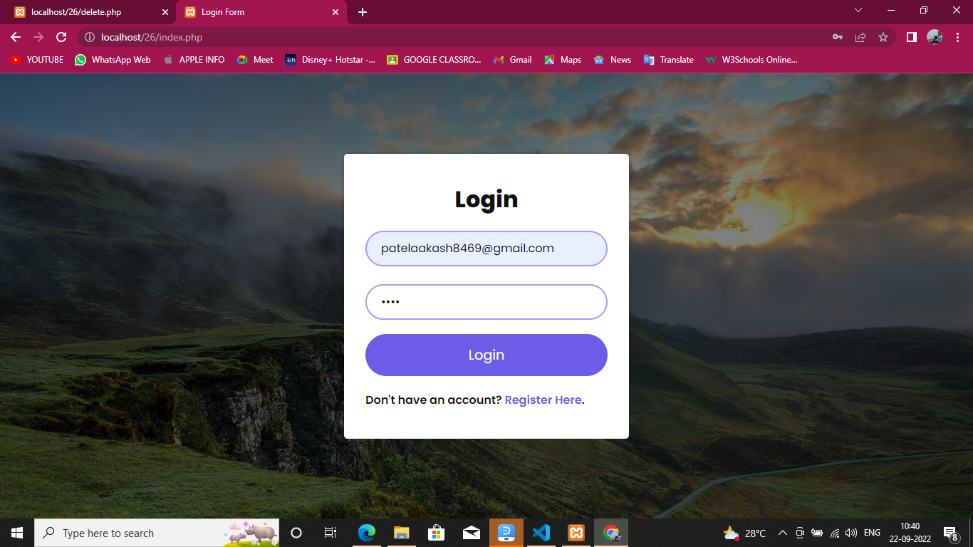

* **REGISTER PAGE:-**

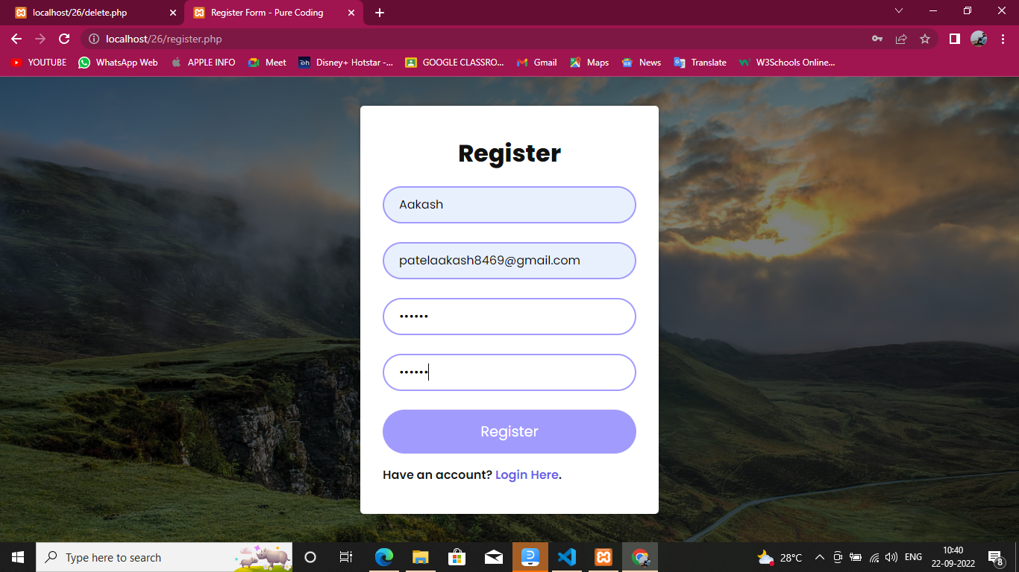

* **26 DATABASE :-**

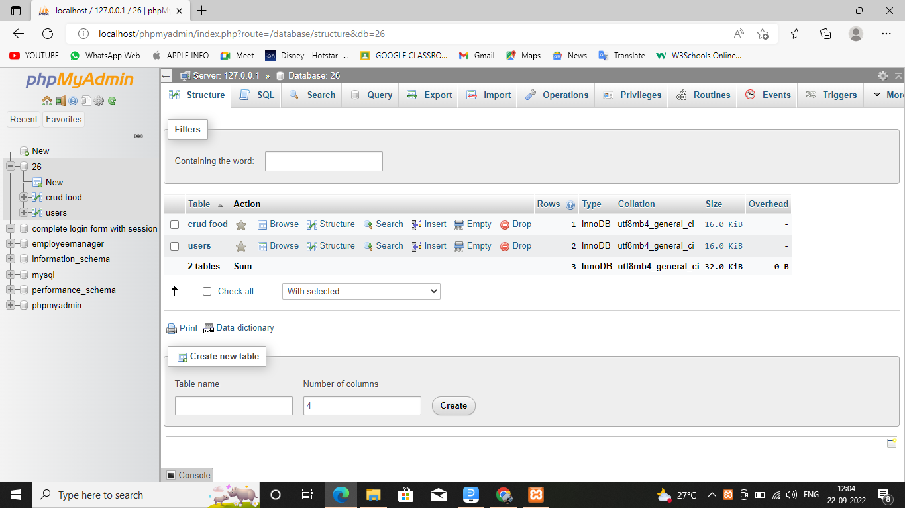

* **HOME**  **PAGE:-**

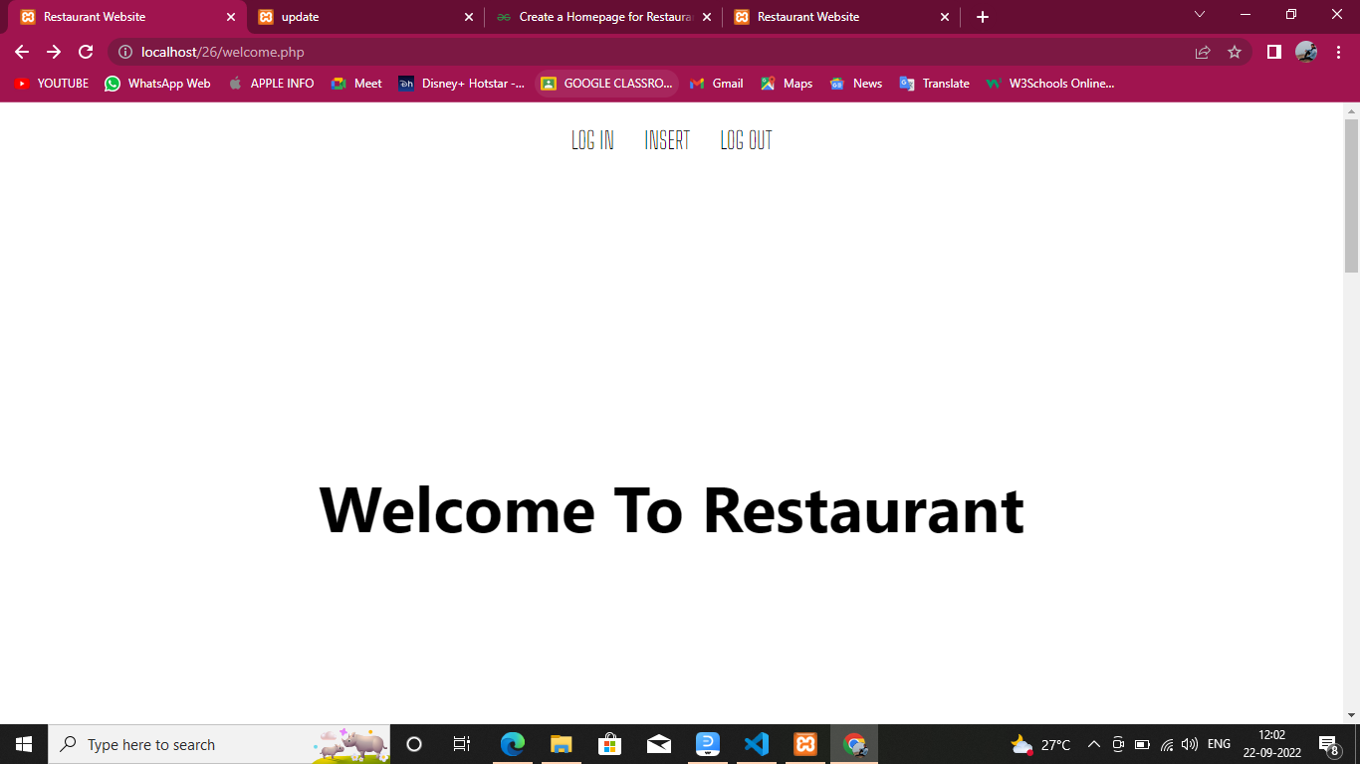

* **INSERT PAGE:-**

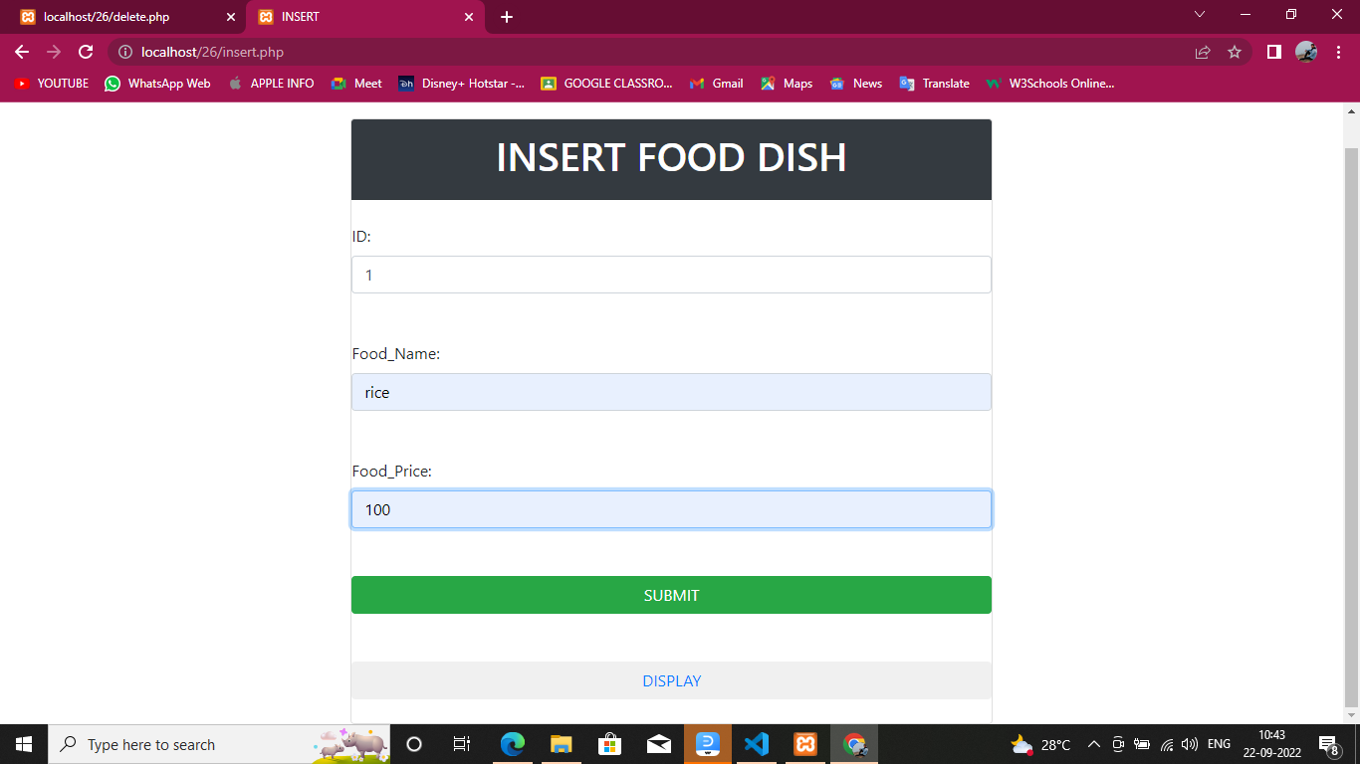

* **DISPLAY**  **DATA:-**

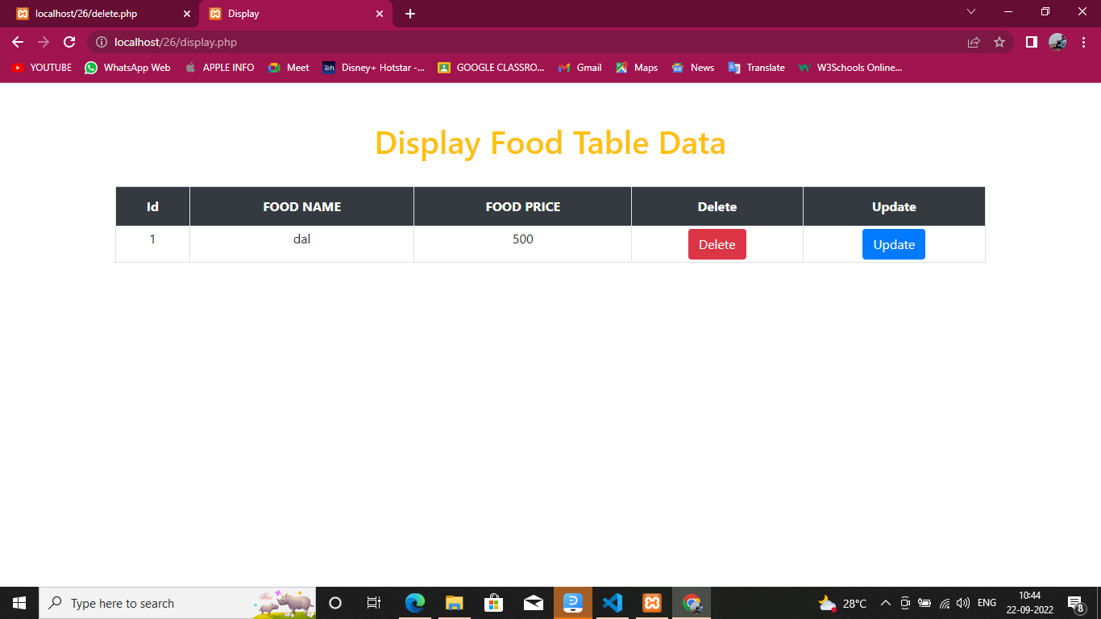

* **DELETE PAGE:-**



* **UPDATE**  **DATA:-**

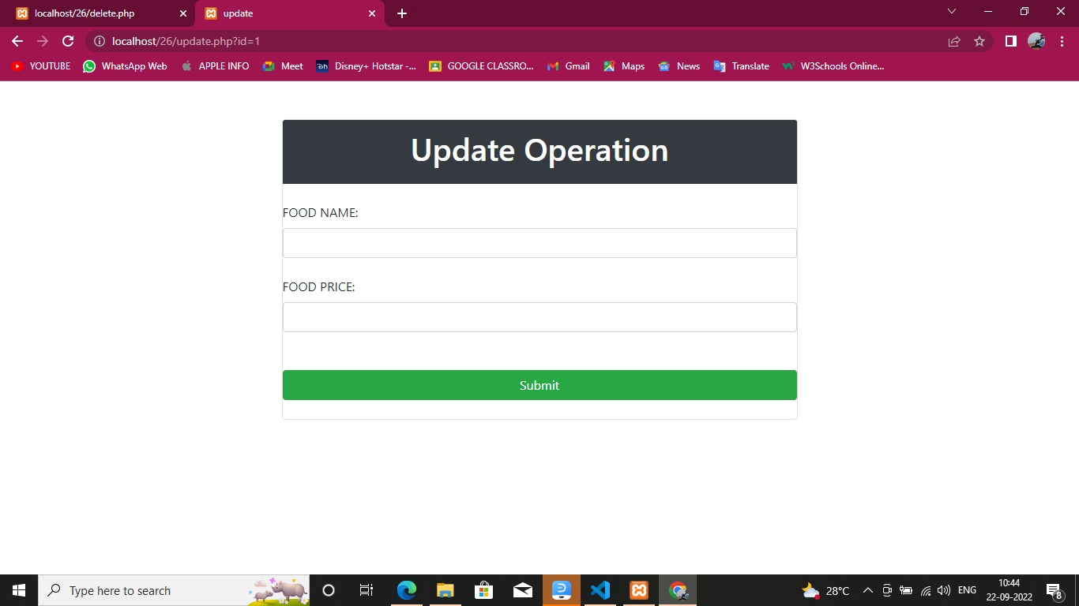

Testing

The testing phase is an important part of software development. It is the puterized system will help in automate process of finding errors and missing operations and also a complete verification to determine whether the objectives are met and the user requirement are satisfied.

**Software testing is carried out in three steps**:

1. Unit Testing

Where in each module is tested to provide its correctness, validity and also determine any missing operations and to verify whether the objectives have been met. Errors are noted down and corrected immediately. Unit testing is the important and major part of the project. So errors are rectified easily in particular module and program clarity is increased. In this project entire system is divided into several modules and is developed individually. So unit testing is conducted to individual modules.

1. Integration Testing

It need not be the case, the software whose modules when run individually and show perfect results when run as a whole. The individual modules are clippemajor module and tested again and verified the result. This is due to poor interfacing, which may results in data being lost across an interface. A module can have inadvertent, adverse effect on any other or on the global data structures, causing serious problems.

1. validation Testing

The final step involves validation and testing determines which the software functions as the user expected. Here also some modifications were. In the completion of the project it is satisfied fully by the end user.

Conclusion

I am very glad to conclude this report; this is My first experience to perform such professional work. Object of this project was to satisfy user’s requirement. Successful implementation of the system, user friendly design and easy to operate system.

It is a great opportunity to learn “online Herbal Shopping” conceptually and Practical knowledge of software engineering, system Analysis system design and real time experience of Project implementation visual web developer C# as Front-end SQL server as back-end.

At least I am thankful to the south Gujarat University to include this Minor project work as a part of our Bachelor degree in computer application (BCA). The Project was really gives chances to earn something out of typical reference books.

Bibliography

[Best PHP Books](https://www.cloudways.com/blog/best-php-books-to-help-you-learn/#php-books)

* + [The Joy of PHP Programming: A Beginner’s Guide – by Alan Forbes](https://www.cloudways.com/blog/best-php-books-to-help-you-learn/#joy-php-programming)
  + [PHP & MySQL Novice to Ninja – by Kevin Yank](https://www.cloudways.com/blog/best-php-books-to-help-you-learn/#novice-to-ninja)
  + [Head First PHP & MySQL – by Lynn Beighley & Michael Morrison](https://www.cloudways.com/blog/best-php-books-to-help-you-learn/#first-php-mysql)
  + [PHP: A Beginner’s Guide – by Vikram Vaswani](https://www.cloudways.com/blog/best-php-books-to-help-you-learn/#vikram-vaswani)
  + [Murach’s PHP & MySQL – by Joel Murach & Ray Harris](https://www.cloudways.com/blog/best-php-books-to-help-you-learn/#murach-harris)
  + [Learning PHP, MySQL, JavaScript, and CSS: A Step-by-Step Guide to Creating Dynamic Websites – by Robin Nixon](https://www.cloudways.com/blog/best-php-books-to-help-you-learn/#creating-dynamic-websites)
  + [Programming PHP – by Kevin Tatroe, Peter MacIntyre & Rasmus Lerdorf “Foreword By: Michael Bourque”](https://www.cloudways.com/blog/best-php-books-to-help-you-learn/#michael-bourque)
  + [PHP & MySQL Web Development – by Luke Welling & Laura Thompson](https://www.cloudways.com/blog/best-php-books-to-help-you-learn/#luke-laura)
  + [PHP & MySQL: The Missing Manual – by Brett McLaughlin](https://www.cloudways.com/blog/best-php-books-to-help-you-learn/#brett-mclaughlin)
  + [Learn PHP & MySQL – Zero to Hero Programming Crash Course – by Paul Madoff](https://www.cloudways.com/blog/best-php-books-to-help-you-learn/#paul-madoff)